Integrating ToDoIst With Teamchat

Step 1: Creating New User

Register In ToDoIst account at https://en.todoist.com.

The Todoist API can be used to hook Todoist with other applications, as it makes it easy for your client to retrieve and sync your data.

Step-2: Authorization
External applications could obtain a user authorized API token via the OAuth2 protocol.

Before getting started, developers need to create their applications in App Management Console and configure a valid OAuth redirect URL.
A registered Todoist application is assigned a unique Client ID and Client Secret which are needed for the OAuth2 flow.

This procedure is comprised of 3 steps, which will be described below.

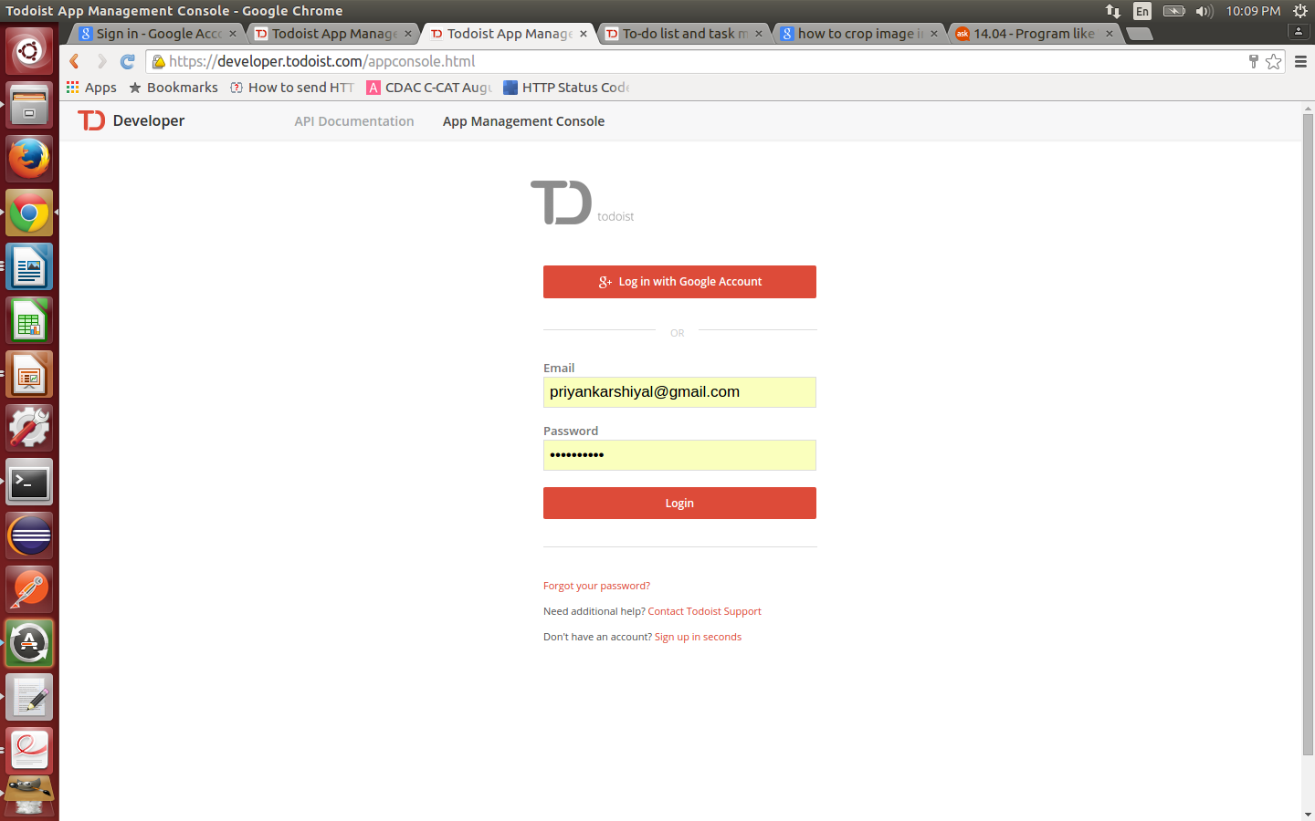

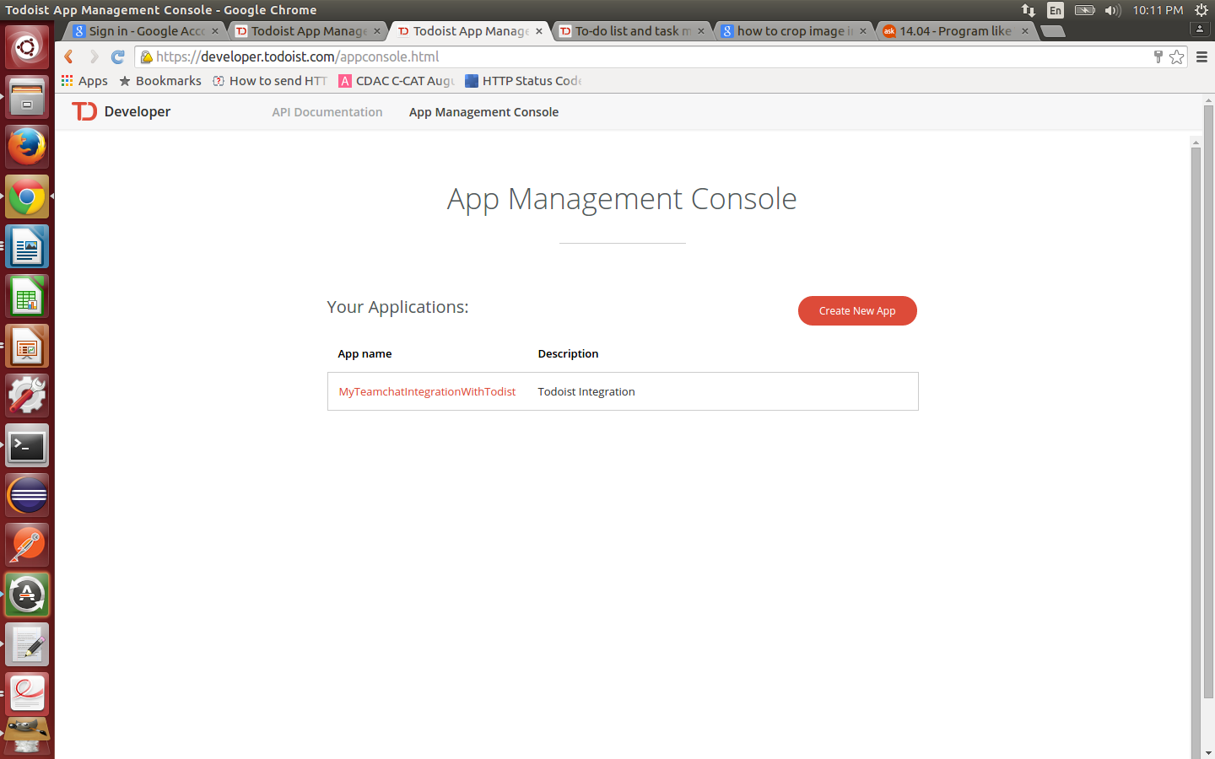

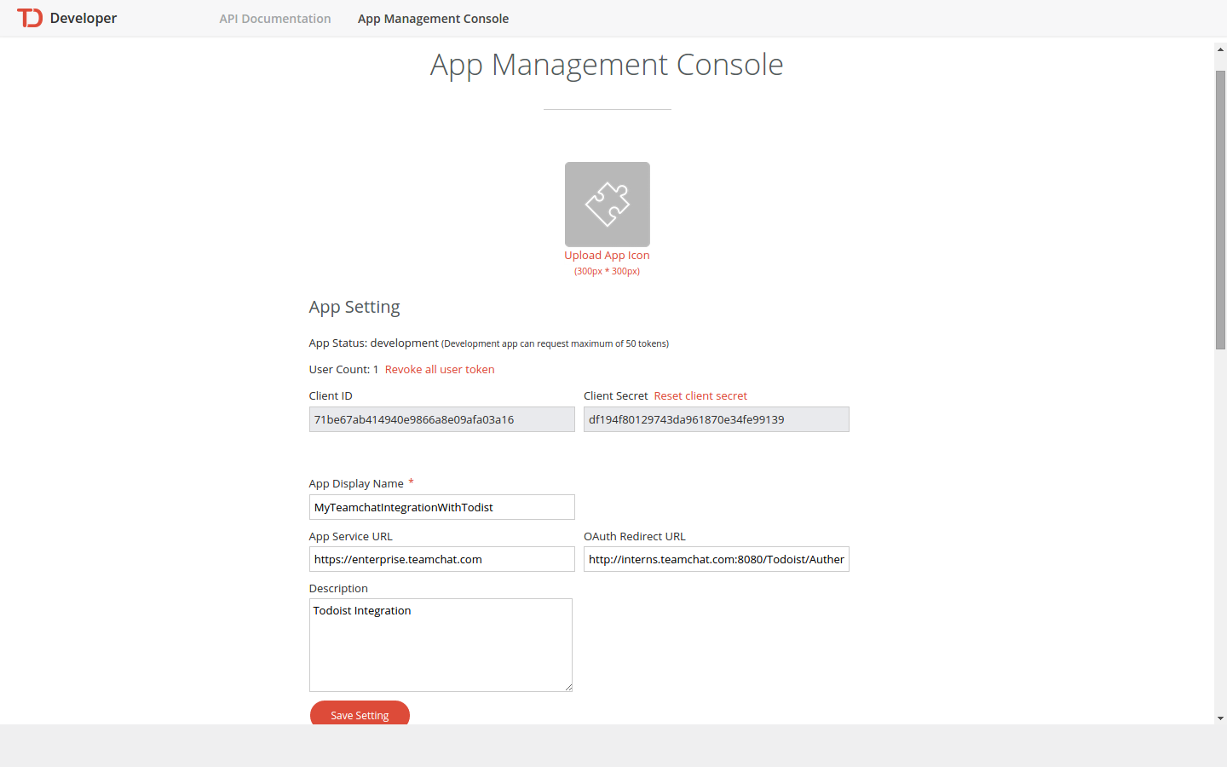

Step 2(a): The authorization request

An example of redirecting a user to the authorization URL:

Url:
$ curl https://todoist.com/oauth/authorize \
-d client_id=0123456789abcdef \
-d scope=data:read,data:delete \
-d state=secretstring
Redirect users to the authorization URL at the endpoint https://todoist.com/oauth/authorize, with the specified request parameters.

Here follow the required parameters:

client_id : The unique Client ID of the Todoist application that you registered.
Scope : A comma separated list of permissions which you would like the users to grant to your application. See below a table with more details about this.
State : A unique and unguessable string. It is used to protect you against cross-site request forgery attacks.

Step 2(b): The redirection to your application site

When the user grants your authorization request , the user will be redirected to the redirect URL configured in your application setting.
The redirect request will come with two query parameters attached: code and state.

The code parameter contains the authorization code that you will use to exchange for an access token.
The state parameter should match the state parameter that you supplied in the previous step.
If the state is unmatched, your request has been compromised by other parties, and the process should be aborted.

Step 2(c): The token exchange
An example of exchanging the token:

Url:
$ curl https://todoist.com/oauth/access_token \
-d client_id=0123456789abcdef \
-d client_secret=secret \
-d code=abcdef \
-d redirect_uri=https://example.com

Once you have the authorization code, you can exchange it for the access token at the endpoint POST https://todoist.com/oauth/access_token.

Here follow the required parameters:

client_id : The unique Client ID of the Todoist application that you registered.
client_secret : The unique Client Secret of the Todoist application that you registered.
Code : The unique string code which you obtained in the previous step

Step 3: Sync Data
The sync API call is used to retrieve data .

Url:
URL: https://todoist.com/API/v6/sync \
-d token=0123456789abcdef0123456789abcdef01234567 \
-d seq_no=0 \
-d seq_no_global=0 \
-d resource_types='["all"]'

Parameters:

token :User’s API token (returned on successful login). Else the session cookie is used.
seq_no : Sequence number. On the initial request you should pass 0. On all other requests you should pass the last seq_no you received from the server.
seq_no_global : Global sequence number. On the initial request you should pass 0. On all other requests you should pass the last seq_no_global you received from the server.
resource_types : This parameter controls which resources to fetch from the server. It can be useful for speeding up the load of most important user’s data (like the list of projects and tasks) and to get the rest of the data asynchronously later on. It should be a JSON-encoded list of strings. For example, ["projects", "labels", "filters"]. Below is the list of recognizable values for strings: projects for the list of projects, items for list of tasks, labels for the list of labels, notes for the list of notes, filters for the list of filters, reminders for the list of reminders, locations for the list of locations, user for the user’s details, live_notifications for the list of live notifications, day_orders for the list of day orders, collaborators for the list of collaborators, and all for all the above. In order to include the notification settings (that is needed on platforms that implement native notifications), the notification_settings has to explicitly be included in the list of resource types.

Step 4: Add a project
An example of adding a project:

Url:
$ curl https://todoist.com/API/v6/sync \
token=0123456789abcdef0123456789abcdef01234567 \
commands='[{"type": "project_add", "temp_id": "4ff1e388-5ca6-453a-b0e8-662ebf373b6b", "uuid": "32774db9-a1da-4550-8d9d-910372124fa4", "args": {"name": "Project4"}}]'

Add a new project.

Required arguments:
name : The name of the project (a string value).

Step 5: Update a project
An example of updating a project:

Url:
$ curl https://todoist.com/API/v6/sync \
-d token=0123456789abcdef0123456789abcdef01234567 \
-d commands=[{"type": "project_update", "uuid": "1ca42128-d12f-4a66-8413-4d6ff2838fde", "args": {"id": 128501815, "indent": 2}}]'

Required parameters
id: The id of the project (a number or a temp id).

Step 6: Delete projects
An example of deleting a project:

Url:
$ curl https://todoist.com/API/v6/sync \
-d token=0123456789abcdef0123456789abcdef01234567 \
-d commands=[{"type": "project_delete", "uuid": "367182ba-125f-4dbb-bff6-c1343fd751e4", "args": {"ids": [128501815]}}]'

Required arguments
ids: List of the ids of the projects to delete (numbers or temp ids).

Step 7: Add Task
An example of adding a task:

Url:
$ curl https://todoist.com/API/v6/sync \
-d token=0123456789abcdef0123456789abcdef01234567 \
-d commands='[{"type": "item_add", "temp_id": "43f7ed23-a038-46b5-b2c9-4abda9097ffa", "uuid": "997d4b43-55f1-48a9-9e66-de5785dfd69b", "args": {"content": "Task1", "project_id": 128501470}}]'

Add a new task to a project.

Required arguments
project_id: The id of the project to add the task to (a number or a temp id).
Content: The text of the task (a string value).

Step 8: Update an item
An example of updating a task:

Url:
$ curl https://todoist.com/API/v6/sync \
-d token=0123456789abcdef0123456789abcdef01234567 \
-d commands='[{"type": "item_update", "uuid": "318d16a7-0c88-46e0-9eb5-cde6c72477c8", "args": {"id": 33548400, "priority": 2}}]'

Required arguments
id: The id of the task (a number).

Step 9: Delete items
An example of deleting a task:

Url:
$ curl https://todoist.com/API/v6/sync \
-d token=0123456789abcdef0123456789abcdef01234567 \
-d commands='[{"type": "item_delete", "uuid": "f8539c77-7fd7-4846-afad-3b201f0be8a5", "args": {"ids": [33548400]}}]'

Delete an existing task.

Required argumentsss
ids List of the ids of the tasks to delete (numbers or temp ids).

